**LINE FOLLOWING ROBOT**

A line follower robot is a robot which follows a certain path controlled by a feedback mechanism.

Building a basic Line Follower Robot involves the following steps.

* Designing the mechanical part or the body of the robot
* Defining the kinematics of the robots
* Designing the control of the robot

A basic Line follower robot can consist of a base at the two ends of which the wheels are mounted. A rectangular sheet of hard plastic can be used as the base. Further a rigid body like a cylinder can be added along with other shaped bodies inter connected with each other by joints, and each with its defined motion in particular direction.  The Line follower robot can be a wheeled mobile robot with a fixed base, a legged mobile robot with multiple rigid bodies interconnected by joints.

The next step involves defining the Kinematics of the robot. Kinematic analysis of the robot involves the description of its motion with respect to a fixed coordinate system. It is concerned mainly with the movement of the robot and with motion of each body in case of a legged robot. It generally involves the dynamics of the robot motion. The whole trajectory of the robot is set using the Kinematic analysis. This can be done using Workspace software.

The control of the robot is the most important aspect of its working.  Here the term control refers to the robot motion control, i.e. controlling the movement of the wheels. A basic line follower robot follows certain path and the motion of the robot along this path is controlled by controlling the rotation of wheels, which are placed on the shafts of the two motors. So, the basic control is achieved by controlling the motors.  The control circuitry involves the use of sensors to sense the path and [the microcontroller](http://www.edgefxkits.com/line-following-robotic-vehicle-using-microcontroller) or any other device to control the motor operation through the motor drivers, based on the sensor output.

**Without using Microcontrollers**

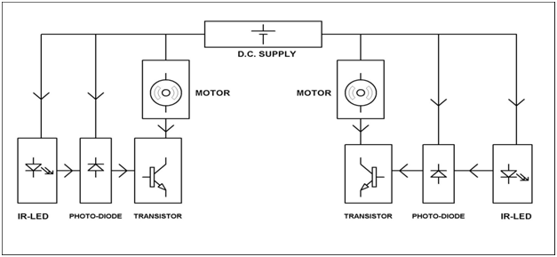

It consists of an IR-LED and Photodiode arrangement for each motor which is controlled by the switching on and off of the transistor.

The IR LED on getting proper biasing emits Infra red light. This IR light is reflected in case of a white surface and the reflected IR light is incident on the photodiode. The resistance of the photodiode decreases, which leads to an increase in current through it and thus the voltage drop across it. The photodiode is connected to the base of the transistor and as a result of increased voltage across the photodiode, the transistor starts conducting and thus the motor connected to the collector of the transistor gets enough supply to start rotating. In case of a black color on the path encountered by one of the sensor arrangement, the IR light is not reflected and the photodiode offers more resistance, causing the transistor to stop conduction and eventually the motor stops rotating.

Thus the whole system can be controlled using a simple LED-Photodiode-Transistor arrangement.

**With using Microcontrollers**

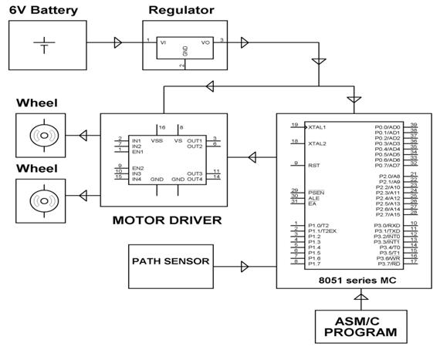

**Different types of line controlled robotic vehicles:**

There are two types of line controlled robotic vehicles

* Mobile based line controlled robotic vehicle
* RF based line controlled robotic vehicle

**Using Vision Techniques**

The line follower robot guided using machine vision consists of the following components

Base

DC motor

Wheels

Microcontroller

Camera

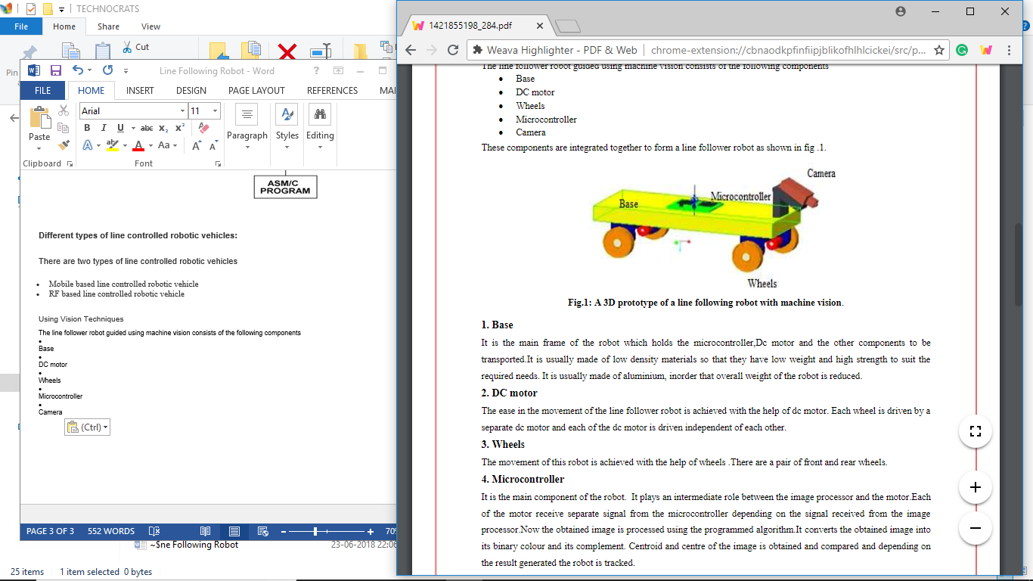

The line follower robot proposed in this paper is guided with the help of machine vision. The camera that is placed in front of the robot captures the track to be followed by the line follower robot .Now the obtained image is processed in the image processing software using the programmed algorithm. The RGB image obtained from the camera is first converted into a gray scale image. Then the grey scale image is converted into its binary image and the complement of the binary image is taken. The complementary of the binary output is in such a way that the background is black in colour and the track is white in colour. Then the centroid of each image is calculated and is compared with the centre of the image. If the centroid of the image coincides with the centre of the image the line follower robot is programmed to go straight. If centroid of the image is shifted to the right of left from the centre of the image the robot is programmed to take a right or left turn. Thus the line follower robot is guided along its track.

**OUTPUT OF SENSOR INTERFACE**

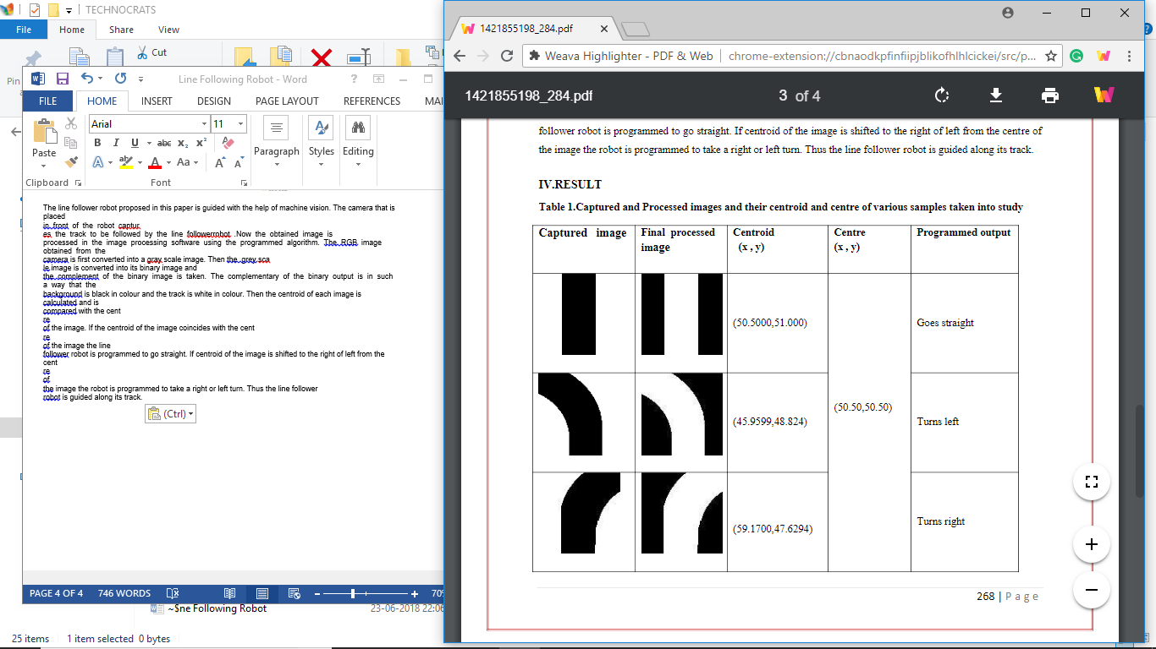

**Using Advanced Auto-Calibrating Line Sensor**

**(LSA08)**

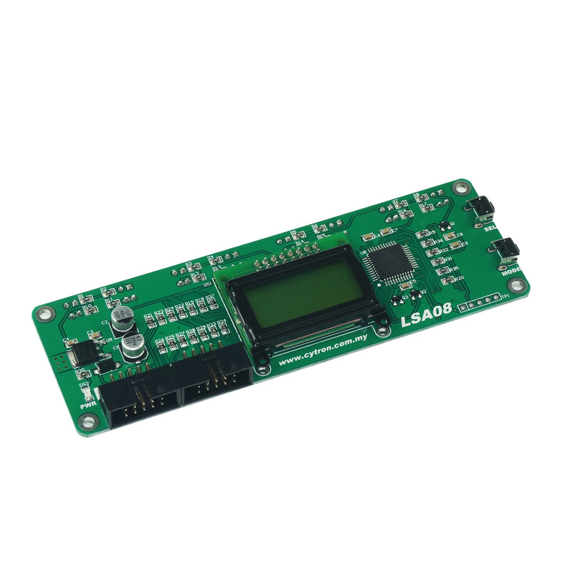

**CLICK HERE:** [**https://tutorial.cytron.io/2015/07/31/line-following-robot-using-lsa08-in-digital-mode/**](https://tutorial.cytron.io/2015/07/31/line-following-robot-using-lsa08-in-digital-mode/)